ARTBARTS Inc. at https://artbarts.com/
The Blockchain ART Simulation (BARTS)
Blockchains help solve problems in both the public and private sectors involving government, business, medical, security, food processing, and transportation applications. To aid in the process of understanding blockchain concepts, we are introducing the Blockchain ART Simulation (BARTS). The simulation illustrates the interrelationship of blockchain mining, cryptocurrency, and hashing concepts. The hash algorithm, SHA3, is used in cryptocurrency mining to make sure that there is no cheating, double spending, and to eliminate denial of service attacks. To participate as a miner, please use a laptop, tablet, or smartphone that is WIFI enabled.
BARTS is a blockchain-based network for buying and selling pencil drawings and sketches (Figure 1). The initial coin offering for the 200 million BARTS tokens took place in July of 2018. Two hundred famous pencil artists received from 1,000 to 20,000 BARTS tokens if they agreed only to sell their pencil drawings through the ARTBARTS network for two years. Over 10,000 gallery owners, investors, dealers, collectors, and even artists purchased 60 million BARTS for approximately $100 million in US funds. There are now over 60,000 artists and buyers participating in the marketplace. BARTS miners use the interactive online mining software for solving a hash problem and adding transactions to the BARTS ledger.
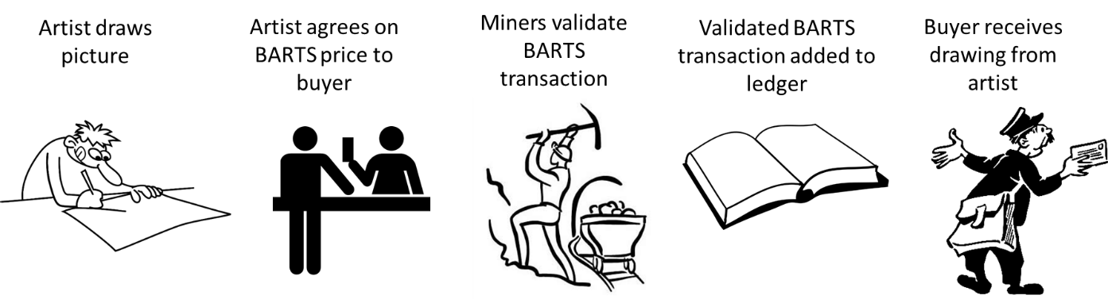
Figure 1 The BARTS Process
Step 1: Identify Artists and Gallery Owners: Instructor will be asking for volunteers to be artists and gallery owners. Do not worry if you are not a good artist.
Step 2: The artists will draw a picture and then negotiate with the three gallery owners offline: Each artist will start drawing their artwork, and then the gallery owners will bid anywhere from 1 to 20 BARTS coins for each drawing. You will negotiate offline. You do not need to spend more than 10 minutes drawing a picture. The artists will then send a picture of the drawing taken with a camera and send it to the instructor with the negotiated price for the drawing. The format of the email is on the next page.
Step 3: Start the mining process and let the hashing begin: The instructor will announce the transaction details that need to be mined. Each member of the class will use the BARTS Mining Program at https://tinyurl.com/BARTSMining to attempt to generate a hash with a leading zero. The miner that finds a hash with a leading zero yells out, “EUREKA.”
Step 4: The instructor adds a valid transaction to the blockchain ledger after obtaining consensus on solving the hashing problem: The instructor asks the individual that yelled Eureka, what nonce value ( random number) generated the leading zero. Transactions validated by at least two other miners/mining pools will be added to the blockchain ledger. The first miner to solve the hash problem will usually get a reward after their transaction is validated.
BARTS Drawing Transaction Email
Please send this email to me the night before the class starts. This email is from the artist and indicates that a price has been negotiated for the drawing.
To: mgtsand@buffalo.edu
From: Ravi
CC: Meenakshy
RE: BARTS Transaction
Meenakshy sends 12 BARTS to Ravi
A picture of the drawing is attached to this email.
When I receive a confirmation that the transaction has been validated, I will send Meenakshy the actual picture by registered mail.

