Teaching note
The Blockchain ART Simulation (BARTS) for Teaching Blockchain Concepts

Sean P. Sanders
Department of Computer Science and Engineering
SUNY-Buffalo, Buffalo, New York 14260
spsander@buffalo.edu

Dr. Bina Ramamurthy
Department of Computer Science and Engineering
SUNY-Buffalo, Buffalo, New York 14260
bina@buffalo.edu

Dr. G. Lawrence Sanders
Department of Management Science and Systems
SUNY-Buffalo, Buffalo, New York 14260
mgtsand@buffalo.edu

The Blockchain ART Simulation (BARTS) for Teaching Blockchain Concepts
“I find it hard to grasp the concept of blockchain in general. Not that I don't understand what it is but to put things together to make a decentralized ledger is quiet (sic) a challenge.”
Abstract
This paper introduces the Blockchain ART Simulation (BARTS). The simulation is used to illustrate the interrelationship of blockchain mining, cryptocurrency, and hashing concepts. We developed the simulation as a way to gamify the learning process and so that students can participate in a simulation for buying and selling drawings. The simulation has been tested on graduate students, undergraduate students, and high school students. The BARTS simulation can have anywhere from 10 to 200 participants. Everyone in the room can participate in the BARTS simulation. The BARTS simulation assists in developing the conceptual foundation for understanding blockchain concepts, hashing concepts and also leads to understanding blockchain-related concepts such as proof of work, proof of stake, immutable ledgers, and digital currency value.
1. Introduction
“…I hate the fact that the concepts are (sic) not relatable. Especially blockchain that requires whole knowledge of web programming, network, business, economics, system analysis .. much more. It’s on another level. I don’t find machine learning or deep learning to be this challenging. Although all these concepts (sic) take a good amount of time to grasp, the blockchain is still harder to grasp and implement.
We believe the primary reason people have a difficult time understating blockchain mining is that the hashing algorithms used in cryptocurrency mining to validate blockchain transactions are conceptually elusive. We hypothesize that understanding the role of secure hashing algorithms in the mining process is the major conceptual impediment for students to gain a true picture of the validation process blockchain transactions. We have found this to be the case even with information technology and computer-science majors. The secure hash algorithm (SHA) appears to be the source of the confusion. Many people have a difficult time understanding what goes on inside the black box where the hashing algorithm does its work. This situation is somewhat ameliorated with the BARTS simulation where hashing concepts are gently introduced during the experiential exercise.
Many students participating in the BARTS simulation have an “aha” experience after they go through just a couple of iterations of the mining process. They still may not understand the inner details of the hashing algorithm, any more than they understand the nuances of why four-stroke engines to produce horsepower by opening and closing exhaust valves, but they do begin to realize that hashes are critical to understanding and controlling the mining process.
Hashing concepts are an important, and often difficult, part of teaching computer security and computer science in general. These complex mathematical secure hash algorithms (SHA) are essential in both computing and blockchain mining because they hold the key to security and authenticity by ensuring the data has not been changed; and this is accomplished by using a complex mathematical algorithm (Maoning, Meijiao et al. 2019). The family of secure hash algorithms are used extensively in cryptography and they have variety of overlapping uses including:
- Ensuring that data on servers has not been changed. Hashing significantly reduces processing time. Hash comparisons replace character-by-character comparisons of files and text to make sure that data has not been compromised.
- Password protection. The hashes are stored instead of the original password. Even if the password files are compromised, the password is not easily recovered by the attacker.
- Digital signatures and fingerprinting. The validity of downloaded software can be checked against a hash on the software developer’s website.
- Proof of work in digital currency mining for blockchain. For example, Bitcoin transactions are hashed until a certain number of leading zeros are obtained.

The next section illustrates how the Blockchain ART Simulation (BARTS) presents an easy entrance into understanding the role of hashing concepts in blockchain and cryptocurrency. It is very useful as a non-technical introduction into cryptocurrency mining, but it is also useful as the foundation for more advanced topics. It can be combined with additional technical materials for those who are interested to reinforce the concepts.
2. Background
2.1 Blockchain Mining and Hashing
Miners and mining pools are used to validate transactions that are written to cryptocurrency ledgers such as Bitcoin. A mining pool is a group of miners that join forces to combine computing power resources to validate ledger transactions (see Figure 1).
The hash algorithm is used in cryptocurrency mining to make sure that there is no cheating, double spending and to eliminate denial of service attacks (Sanders 2018; Sungmin and Joongheon 2018). This is accomplished by controlling the difficulty of the mining process by requiring that a certain number of leading zeroes are part of the hash that is written to the blockchain. At this point, Bitcoin miners are required to produce transaction’s hashes with 17 leading zeros and the first mining company to find a hash with 17 leading zeros also receives 12 Bitcoins. Miners within a large mining pool are paid according to their proportional hashing power if they find the hash with the appropriate number of leading zeros.
The underlying concept of the hashing algorithm behind blockchain mining can be traced to the 1970s. However, sophisticated hashing algorithms did not emerge until the late 1990s. These algorithms included the original 128-bit MD5 hash algorithm 160 bit SHA1(Jordan 2018).

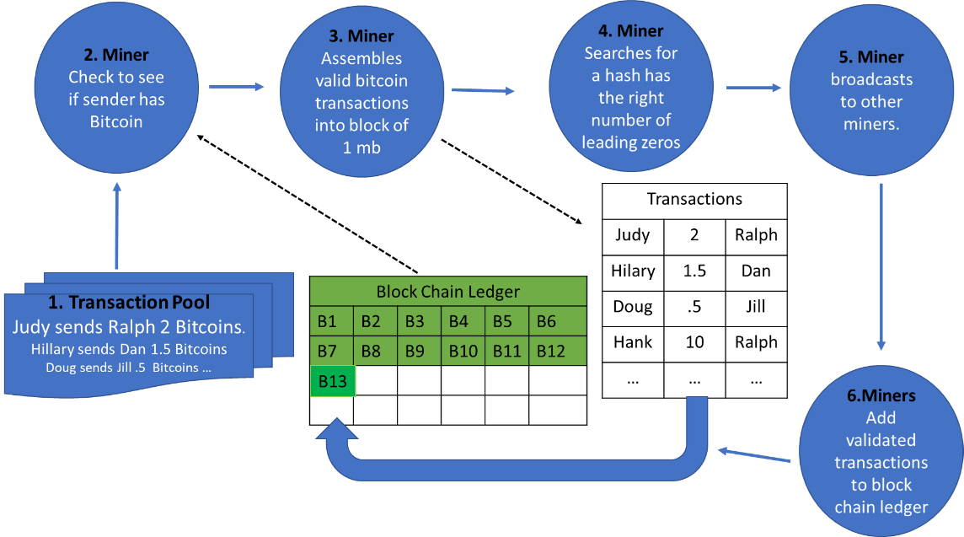
Figure 1: The Mining Process
2.2 Hash Functions Ensure that Data has not been changed
As noted earlier, hash functions are used to verify that data has not been changed. A hash function is used to map data back to a specific set of data of a predetermined size (see Figure 2). Hash security is controlled in part by the number of bits that make up the hash. The least secure hashes, such as the MD1 with 120 bits and SHA1, with 160 bits have been superseded by more recent and more secure hashing algorithms including SHA 256, SHA384 and SHA512. The number of unique hashes is related to the number of bits in a hash. 2¹⁶⁰ is a very large number 1.4615e+48, but 2⁵¹² is unfathomable at 1.3408e+154. In fact, both of them are unfathomable.
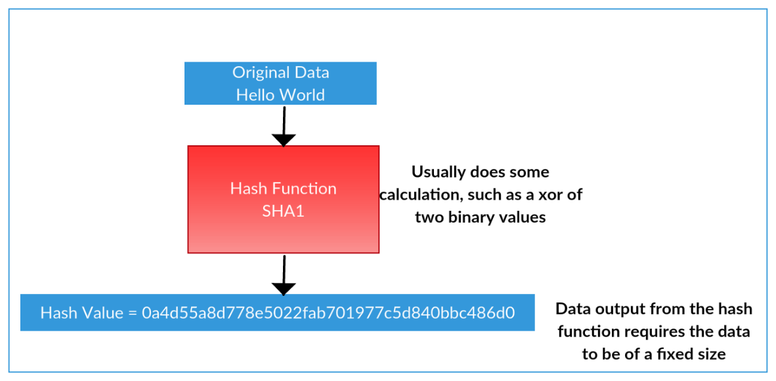
Figure 2 Hashing Algorithm Results in a Hash Value
If you want to check if any value in a stream of characters has changed, you can check the hash value. A verified hash value indicates that the original data remains untouched. If the hash value does not match the hash value from the original data, then the data has been altered or tampered in some way. This is, in part, how the double spending problem is countered, and man-in-the-middle attacks are mitigated. In the case of the blockchain, they are used to ensure that the data blocks have not been modified and act as a verification system for miners (Sanders 2018). Figure 3 illustrates how hashing works to prevent a so-called Man-in-the-Middle attack.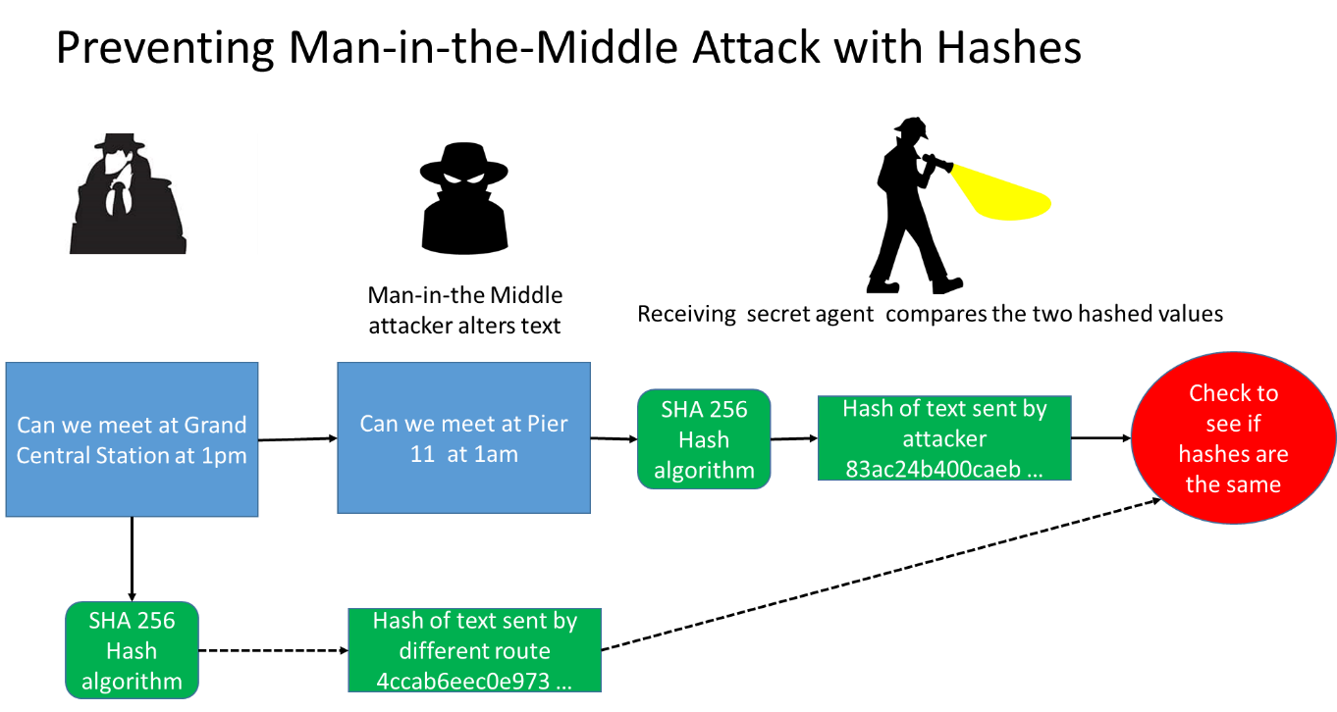
Figure 3 Man-in-the-Middle Attack
3. BARTS Simulation
The BARTS simulation is a non-technical simulation where participants mine or validate a digital coin transaction for buying and selling drawings (see Figure 4). The BARTS simulation is used to illustrate the role that hashing provides in the mining process, how transactions are processed on the blockchain, the market demand for cryptocurrency, the role of smart contracts validating transactions, how the ledger is updated, and how gas can be used to reduce transaction times.
The BARTS simulation can have anywhere from 10 to 200 participants. Everyone in the room can participate in the BARTS simulation. Participants should bring a laptop to the exercise, but they can also use a smartphone or a tablet with wifi access to the internet to participate in the mining process.
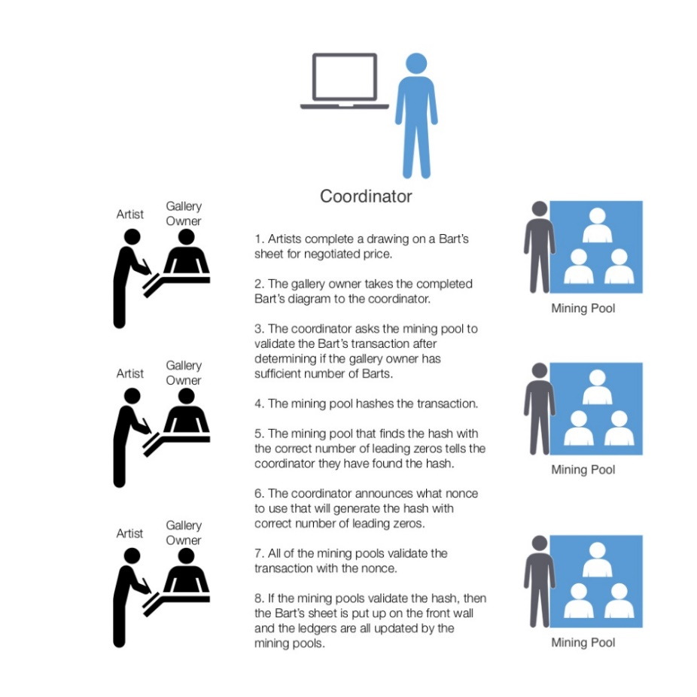
Figure 4 Overview of BARTS Cryptocurrency Simulation
3.1 The BARTS Mining Process
The instructor is the coordinator for the BARTS simulation. You need at least ten people to play the simulation effectively (two artists, two art buyers, and three mining pools with two people in each pool). The simulation is set up so that the artists, gallery owners, and mining pools have names. It is not necessary, but it helps to clarify the roles of the players. We like to use the same names for the simulations, but you can use any names. As noted earlier, the exercise can be adapted to any class size by adding more people to each mining pool or by reducing the number of mining pools. Artists and buyers can also be added.
Table 1 BARTS Players
Artists Names  DrawGud  Crafty  Charkole  Gallery Owner Names  Flipflop  Krystal  Bobo | Miner Pool Names  Placer Kings  Gold Gulch  Spider Miners  Dig It Fast  Royal Placer  Barts Miner  Hash Crash  Fire Ants

Step 1: Identify Artists and Gallery Owners
Ask for volunteers to be artists and gallery owners. If no one is volunteering, then assign them to the roles. Be sure to tell them that they do not have to be good artists. After you get your volunteers, have the artists sit on one side of a table and the gallery owners on the other side. You can also use desks. Give each artist a copy of the BARTS transaction paper along with a number 2 pencil. They will draw a simple picure of picture on the paper.

Step 2: Identify Mining Pools and Miners
You need at least three mining pools with two miners in each pool. We usually create tents (for Placer Kings, Gulch Miners etc.) with the name of each mining pool on the tent. We then put the tent on one person’s desk and then just point at people around the tent and assign them to a pool. About five people in a mining pool works best. The main activity of the miners is to find a nonce that generates a leading zero on the hash. In actual mining for Bitcoin cryptocurrency, a nonce is a random number or pseudo-random number that is added to the text to make sure that text and numbers have not been modified during transportation.
Step 3: Tell the artists to start drawing
The sellers or artists (Drawgud, Crafty, and Charkole) then draw a picture in under two minutes on the BARTS transaction paper (see Figure 1). After the drawing is completed, the gallery owners then bid anywhere from 1 to 5 BARTS coins for a drawing . The first artist and gallery owner that agree on the amount will then fill out the BARTS transaction sheet and deliver to the instructor. The BARTS transaction paper is on the back of the case directions.
Step 4: Start the Mining Process
The instructor is like the core blockchain coordinating software. He or she announces the transaction to everyone in the room. Each member of the mining pool will use the BART Mining Program at https://tinyurl.com/BARTSMining to find a nonce that will generate a hash with a leading zero. If there is only one miner, then this would take, on average, 16 iterations. If there are many participants in the simulation, then the number of zeros could be changed to two. That would take approximately 16^² (256) attempts. This is how mining complexity is controlled in many cryptocurrency applications. One leading zero is usually sufficient to slow down the process for the BARTS simulation. We asked that the individual that finds a hash with a leading zero yells out “Eureka.”
Step 5: Instructor Adds Valid Transaction to the Ledger
The instructor asks the individual that yelled Eureka what nonce value generated the leading zero. The instructor then announces the nonce value to all of the miners. If a majority (e.g., 2 out of 3 pools) of the mining pools can generate a hash with the same leading zero and hash, then the instructor adds the transaction to the blockchain using https://tinyurl.com/BARTSBlockchain.
When you first run the ledger program a file name is required for the ledger. Just use any unique name for the ledger each time you start a new BARTS simulation. For example, MaryBlock1 or MaryBlock2. Use a new name each time you run the program.
You can also have each mining pool run the PHP-based ledger and have them add a transaction to their blockchain ledger. This is approximately the way a distributed ledger works. However, the first time you run this it is a good idea to have just the instructor add to the ledger, to keep it simple.
As an example, Figure 5 illustrates how a transaction between an artist and a gallery owner is eventually entered into the ledger after at least half of the mining pools validate that the nonce of 34 will result in a hash with one leading zero. Again, this is essentially the way that mining time is controlled by a Bitcoin type of currency. The simulation should be run at least three times for the participants to get a good feel for the process.
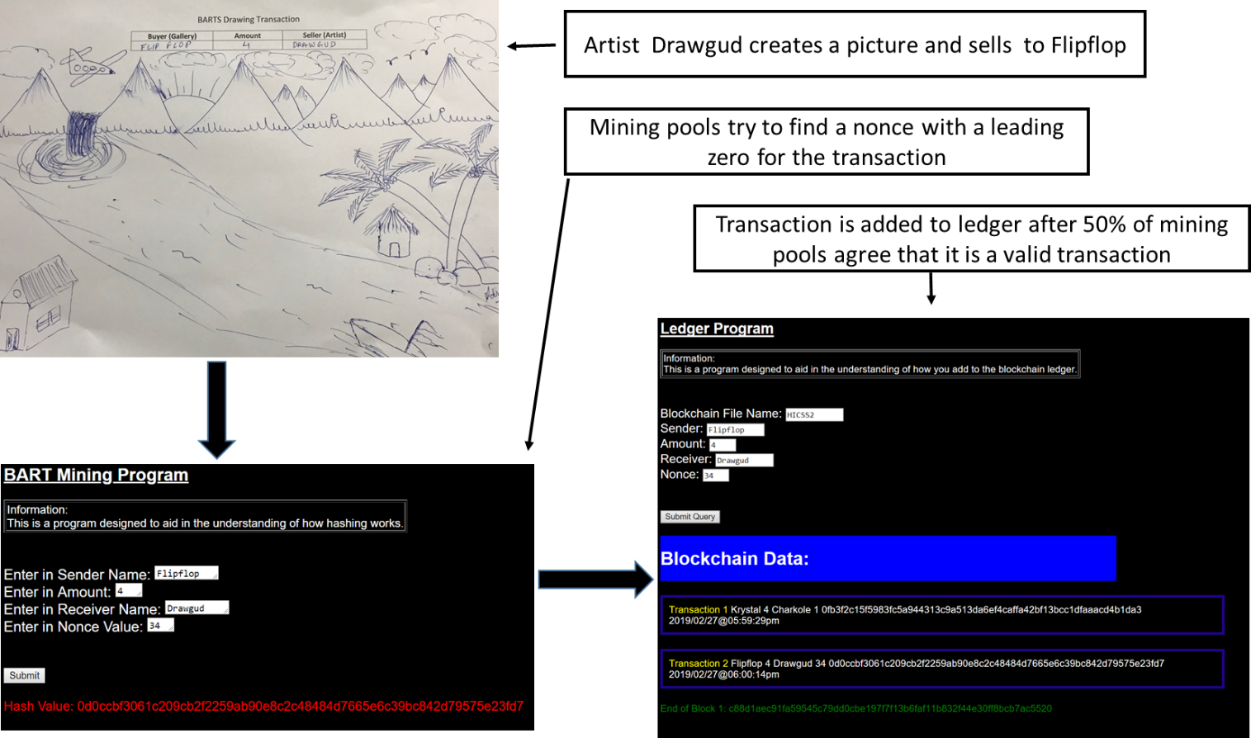
Figure 5 Adding a transaction to the BARTS ledger
Step 6: Debriefing
After the simulation is completed, we debrief the students and discuss the following critical issues.
Transaction Processing: We discuss how transactions are processed and added to a blockchain ledger in this simulation and how transactions are added with a real cryptocurrency. In this simulation, the instructor is the coordinator for the entire BARTS systems and is the only one that is permitted to add transactions to the ledger. In a distributed network, multiple copies of the ledger reside with the miners, developers, and whoever is part of the transaction validation process. This simulation is very flexible, and you can have each mining pool add to their own unique ledger. They just run the ledger program with a unique name and then add validated transactions to their unique ledger. However, this adds more complexity to the simulation, and you should gain some experience with the simulation before you attempt a distributed ledger validation process.
Proof-of-Work: Proof of work and consensus is an important part of understanding cryptocurrency concepts. The number of leading zeros required, or the mining complexity leads to proof of work. In the BARTS simulation, the transaction is only added to the blockchain ledger after 50% or more of the mining pools indicate the nonce with the original text has a leading zero. By the way, the ledger will not let you add a transaction to the ledger unless it has a leading zero in the hash.
Proof-of-Stake: Proof of stake is an alternative to proof work and proof of consensus. In Etherium-type ledger validation, a random drawing takes place to determine what mining pool will validate the blockchain transactions. Each miner pool participates in the drawing is based on the amount of hashing power and gas the mining pool possesses.
Gas in Etherium-type blockchains: In Etherium-type ledgers, you can pay additional cryptocurrency to have your transaction added to the blockchain faster. This is called gas, and it can be used to reduce transaction times.
Research and Development: The BARTS simulation can illustrate how R&D can be used to reduce the time to find a hash with a leading zero and increase mining performance. For example, process innovation would occur when miners in a mining pool start at different numbers for the nonce. For example, if there were three miners, one miner could start at 1, the second at 11, and the third at 20. Another way to increase mining performance is to find or develop a program to automatically generate a hash with a leading zero. Of course, the instructor could then have the miners generate a hash with more leading zeros.
Mining Complexity is Controlled by Several Leading Zeros: The number of leading zeros required for a transaction can be used to control the speed of the mining process. If we had a room with 200 miners, we could have them generate a hash with two leading zeros. That would on average take 16^2 or 256 attempts to find a text with two leading zeros.
How Would Smart Contracts Work in BARTS: Smart contracts are programs, code, protocols, or scripts controlling when and how of cryptocurrency is transferred between parties or the when and how of non-blockchain transactions. We might have a smart contract that puts the minimum amount that could be paid for a drawing is 5 BARTS, or that after a gallery owner purchases three drawings from one artist, the gallery owner gets a 1 BARTS discount from the artist.
Digital Currency Market Demand Concepts: Drawings can only be bought and sold through the BARTS market using the BARTS transaction paper. Before the simulation was started, 1 million BARTS cryptos were sold at an initial coin offering. People purchased the BARTS using a credit card or direct deposit.
Names of BARTS Participants Would Be Encrypted in An Actual Crypto Application: The name of the parties participating in the BARTS transactions would be hashed encrypted signatures. No names are involved with true cryptos. The process of validation would involve something like the elliptic curve cryptography (Jonathan 2015). This is a very technical topic that could be covered in more technical courses. It is essentially a secure user-id/password-type validation procedure.
The debriefing often results in several “aha” moments by the participants and sets the stage for the technical material that follows. The BARTS simulation can be used as a stand-alone overview of blockchain concepts for high school students, undergraduates, and the general public. But it also serves as a very effective foundation for the technical material on secure hashing algorithms. Powerpoint slides that can be used for the simulation can be downloaded from https://tinyurl.com/BARTSPowerPointSlides.

4. Additional Technical material on Hashing
A set of four exercises were developed to illustrate hashing concepts. The four exercises take about an additional hour or two of class time depending upon the level of detail need to discuss the concepts. They can be introduced before or after the BARTS simulation and present additional insight into the hashing concepts. However, we have found that introducing the BARTS simulation first is more effective. Even though the exercises are based on technical material, they are very easy to follow because they use online PHP programs to illustrate the concept. The exercises were adapted and used as the foundation for developing the BARTS simulation. Here are the exercises:
- Exercise 1: Generate a nonce that will result in a leading zero for a hash. Students enter their name with the number 1 right after their name. If the first character is not a zero, they keep incrementing the number following their name by one more unit until a hash with one leading zero is generated. This program is available at https://tinyurl.com/ZeroHashMining.
- Exercise 2: A Hashing program that automatically searches for a nonce. This algorithm is quite complex because the program has to keep searching until it finds a hash with the correct number of leading zeros. This is what miners do for a living using specialized hardware using hash speeds of hashes to find a hash with 17 leading zeros. This program is written in PHP and is available at https://tinyurl.com/ZeroHashMining2.
- Exercise 3: Mining Computation Issues: The purpose of this exercise is to illustrate in greater detail the computational demand that is required for using hashing for proof of work. It requires participants to enter the text to be hashed, along with the number of leading zeros, then to click on the hashing algorithm desired and the number of times to run the simulation. The program will find the hash by adding a nonce, or random number, to the string until it generates a hash with the appropriate number of leading zeros. This program is available at https://tinyurl.com/ZeroHashMining3.
- Exercise 4: Birthday Paradox and cracking secure hash algorithms: The safety of secure hash algorithms is always an issue of interest. The Birthday Paradox can be used as an approximation of the amount of brute force computing necessary to find a hash collision. The program used to illustrate the number of years to find a hash Collison for various SHA bit sizes and hash rates can be found at https://tinyurl.com/BirthdyaParadoxExample. For example, the number of years needed to find a collision for the lowly 160 bit SHA1 algorithm using 5,000 ASICS computers each capable of 13TH/s with a total hashing rate of 65,000 TH/s, is 0.74 years. This is in contrast to the 208.06 trillion years to find a collision with the SHA256 algorithm using the brute force approach.
We have found that the BARTS simulation is a good way to introduce hashing concepts, but for more technically inclined students, the hashing process needs additional discussion because of its importance to several security concepts. The four additional exercises were developed to illustrate hashing concepts round out the concepts. They are usually introduced a day or two after the BARTS exercise is completed. These exercises are coordinated by the instructor. However, class participation is the cornerstone of these exercises. The participants bring a laptop, a smartphone, or tablet to the session. The only thing that is needed is a connection to the internet.
Conclusion
As noted earlier, the simulation has been tested on graduate students, undergraduate students, and high school students. For example, we have used the material discussed here to teach 130 Masters of Science students of Management Information Systems. We also had the students do the third session on a Harvard Case entitled: Bitfury: Blockchain for Government by Mitchell Weiss and Elena Corsi (Corsi and Elena 2019). This eventfully translated into three one and a half hours’ sessions on blockchain, hashing, and cryptocurrency concepts. Some of the students in the course became so engrossed with the technology that they also developed a mock-up a blockchain application. We are also developing a set of exercises that can be used to understand and deploy smart contracts using the solidity environment with Ethereum.
At the end of the sessions, we had the students in the course fill out an anonymous survey on the three modules. The survey questions and corresponding results are as follows.
Question 1: The material covered in the blockchain teaching module helped me gain a clearer understanding of blockchain concepts (1 Strongly Disagree to 5 Strongly Agree).
The mean was 4.1 with 108 respondents
Question 2: What is the percentage of a new understanding of blockchain concepts did you get from the teaching module?
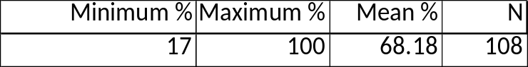
The results of the survey were positive. We are pleased with these results, given that many of the individuals in the class had extensive experience in systems development and applications programming.
Teaching blockchain and hashing concepts are much easier when the teaching pedagogy is interesting. We think the approach used here establishes a strong foundation for understanding hashing concepts and also creates an opportunity for evaluating and discussing contemporary blockchain concepts.

References

- Corsi, M. W. and Elena (2019). "CASE: Bitfury: Blockchain for Government." Harvard: 29.
- Jonathan, K. Y., Lindell (2015). Introduction To Modern Cryptography Second Edition, Chapman and Hall/CRC.
- Jordan, R. (2018, 2018-07-23). "The State of Hashing Algorithms — The Why, The How, and The Future." Retrieved 03/15/2019, 2019, from https://medium.com/@rauljordan/the-state-of-hashing-algorithms-the-why-the-how-and-the-future-b21d5c0440de.
- Maoning, W., D. Meijiao and Z. Jianming (2019). "Research on the Security Criteria of Hash Functions in the Blockchain." ACM: 47-55.
- Sean, S. (2018). POSTER: Examining the Performance of Hashing Algorithms for Digital Currency Mining. Consortium for Computing Sciences in Colleges, Marymount University, Arlington, VA.
- Sungmin, K. and K. Joongheon (2018). "POSTER: Mining with Proof-of-Probability in Blockchain." ACM: 841-843

https://www.reddit.com/r/ethereum/comments/92z4ok/how_difficult_is_blockchain_technology_to/

